HW 6.3: Tie it together
- Let’s determine if there is a treatment effect of drug on pulse rate.
Hypotheses:
Let m_{A}, m_{B} and m_{C} respectively be the average of pulse rate of the snakes to which treatments A, B and C were administered.
H₀: m_{A}=m_{B}=m_{C}
Ha: At least one mean different
Assumptions:
- The data is made up of basic random values drawn from the population.
- First, we test the hypothesis of normality of the dependent variable therefore the pulse rate of the snakes

Since the p-value=0.044<0.05, implies that data distribution are different from the normal distribution. Hence we cannot assume normality.
- Next, we will test the hypothesis of equality of variances between the groups.


Since the p-value=0.194>0.05, implies that it is possible for the variances to be equal.

We therefore conduct a hypothesis test to test if there is a treatment effect of drug on pulse rate

Code:
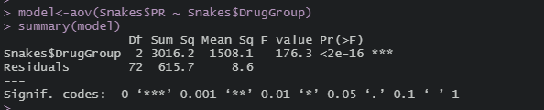

Conclude and interpretation:
With an alpha of 0.05 and p-value<2e-16, we reject the null hypothesis and state that we have sufficient evidence to support that there is a treatment effect of drug on pulse rate.

Let’s determine (if possible) which drug reduced the pulse rate in snakes the most.

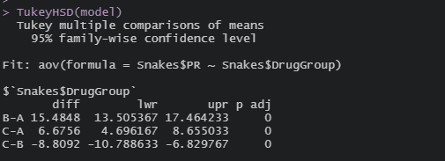

Drug B has a higher estimated pulse rate than drug C, by approximately 8.8092 (p-value ~0). Drug C also has a higher estimated pulse rate than drug A, by approximately 6.6756 (p-value of ~0). Thus, drug A is the one that reduces the pulse the most.

- Let’s determine if there is a drug effect on weight.
Hypotheses:
Let m_{A}, m_{B} and m_{C} respectively be the weight average of the snakes to which treatments A, B and C were administered.
H₀: m_{A}=m_{B}=m_{C}
Ha: At least one mean different

Assumptions:
- The data is made up of basic random values drawn from the population.
- First, we test the hypothesis of normality of the dependent variable therefore the weight of the snakes.


Since the p-value=0.921>0.05, implies that data distribution follows the normal distribution. Hence we assume normality.

- Next, we will test the hypothesis of equality of variances between the groups.


Since the p-value=0.2404>0.05, implies that it is possible for the variances to be equal.

We therefore conduct a hypothesis test to test if there is a drug effect on weight.

Code:
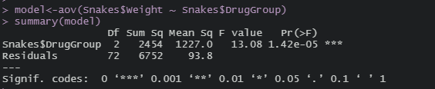

Conclude and interpretation:
With an alpha of 0.05 and p-value of 1.42e-05, we reject the null hypothesis and state that we have sufficient evidence to support that there is a drug effect on weight.

Let’s determine (if possible) which drug increased snakes weight the most.
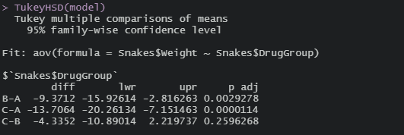

Snakes taking drug A have a higher estimated weight than those taking drug B, by 9.3712 (p-value~0.0029278). Those taking drug A also have a higher estimated weight than those taking drug C, by 13.7064 (p-value~0.0000114). Thus, drug A is the one that increases the weight of snakes the most.

- Let’s determine if there is a drug effect on length.
Hypotheses:
Let m_{A}, m_{B} and m_{C} respectively be the length average of the snakes to which treatments A, B and C were administered.
H₀: m_{A}=m_{B}=m_{C}
Ha: At least one mean different
Assumptions:
- The data is made up of basic random values drawn from the population.
- First, we test the hypothesis of normality of the dependent variable therefore the length of the snakes.
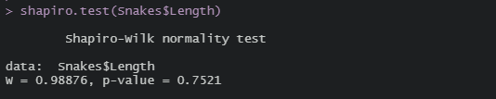

Since the p-value=0.7521>0.05, implies that data distribution follows the normal distribution. Hence we assume normality.

- Next, we will test the hypothesis of equality of variances between the groups.


Since the p-value=0.4967>0.05, implies that it is possible for the variances to be equal.

We therefore conduct a hypothesis test to test if there is a drug effect on length.

Code:


Conclude and interpretation
With an alpha of 0.05 and p-value of 0.844, we fail to reject the null hypothesis and state that we have insufficient evidence to prove that there is a drug effect on length.

